eLearning, or online learning, has reached every corner of the globe in this era of digitization. As a result of the COVID-19 pandemic, the value of eLearning has increased substantially. In eLearning recommendation systems, information overload, personalised suggestion, sparsity, and accuracy are all major problems. The correct eLearning Recommendation System is necessary to tailor the course recommendation according to the user's needs. To create this model, dataset of the User Profile and User Rating is needed. The User Profile dataset is created by using the Calyxpod programme to collect student profiles. User requirements are available through these profiles. The dataset obtained by gathering student comments following course completion is in the range of 1 (lowest) to 5 (highest).

We have generated a dataset using the following settings:

*To generate the dataset calyxpod tool is used. This tool collects the student’s profile of the Engineering students based on the required parameters named User Profile. User Rating is the matrix of the user id (taken from User Profile) and the ratings (in the range of 1 to 5) per course given by each user.*

*The dataset folder includes .csv files of User Profile dataset and User Rating dataset.*

*User Profile dataset parameters are: User Id, Degree, Degree Specialization, Known Languages, Keyskills, Career Objective.*

*User Ratings parameters are: User id, Course id and rating.*

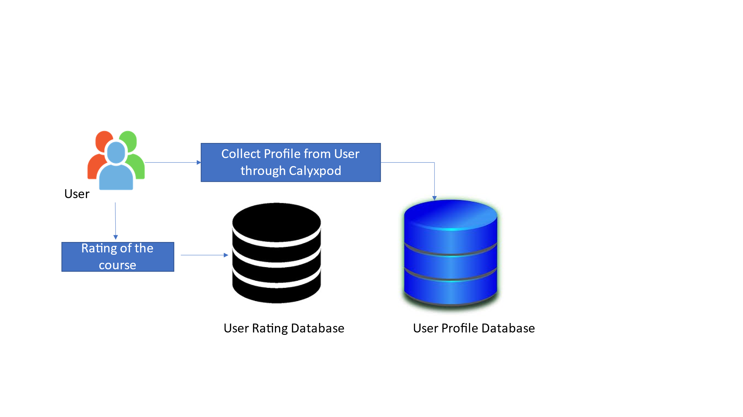

***How to Use:***

*These two datasets can be used together as they are required for personalized course recommendation. This dataset can be used for eLearning or course recommendation system using different methodology or approaches.*